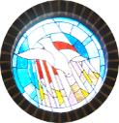

Church of The Holy Spirit Bardfield and the church of The English Martyrs Thaxted: registration form for First Holy Communion children.

Child’s full name
Parents names (first and surname)
Child’s Date of Birth
Child’s date of Baptism
Child’s usual parish
Parents mobile number

Any other information e.g Medical / additional needs the child has which need to be taken into consideration:

